C&E Explorer — User Manual
Oct 31, 2026 · @Badr
C&E Explorer answers one question fast: what does this signal trip, and what trips it? You import the plant's cause & effect (C&E) charts from Excel once, then type any tag to see every effect it initiates, every cause that acts on it, its set point, its notes, and the packages it belongs to.

What the app is
The app replaces the CE_search_37 macro workbook with a page that opens in any browser and needs no installation, macros or internet.
- Cause: an input that starts an action, such as a push button, a confirmed fire/gas zone or a high-high level transmitter (rows of a C&E chart).
- Effect: what is acted on, such as a shutdown valve, a blowdown valve, a pump trip or an ESD level (columns of a C&E chart).
- Action code: the mark where a cause meets an effect: X (immediately), T… (after a delay), A (abort), C/O (close/open) and so on. The full list is in Action codes.
- Trip chain: when an effect is itself a cause on another sheet (for example an ESD level that closes valves), the app follows it so you see the whole sequence.
Everything you import is read inside your browser and kept there. Nothing is uploaded, and your Excel files on disk are never changed.
A 2½-minute captioned walkthrough video, C&E_Explorer_walkthrough.mp4, sits in the same folder as the app and shows every step below.

Getting started
Open CE_Explorer.html by double-clicking it, or open the team's web link if the app is hosted. It works in current Chrome, Edge and Firefox, offline and from a shared drive.
The first time you open it, the page is empty and asks for your C&E workbooks:
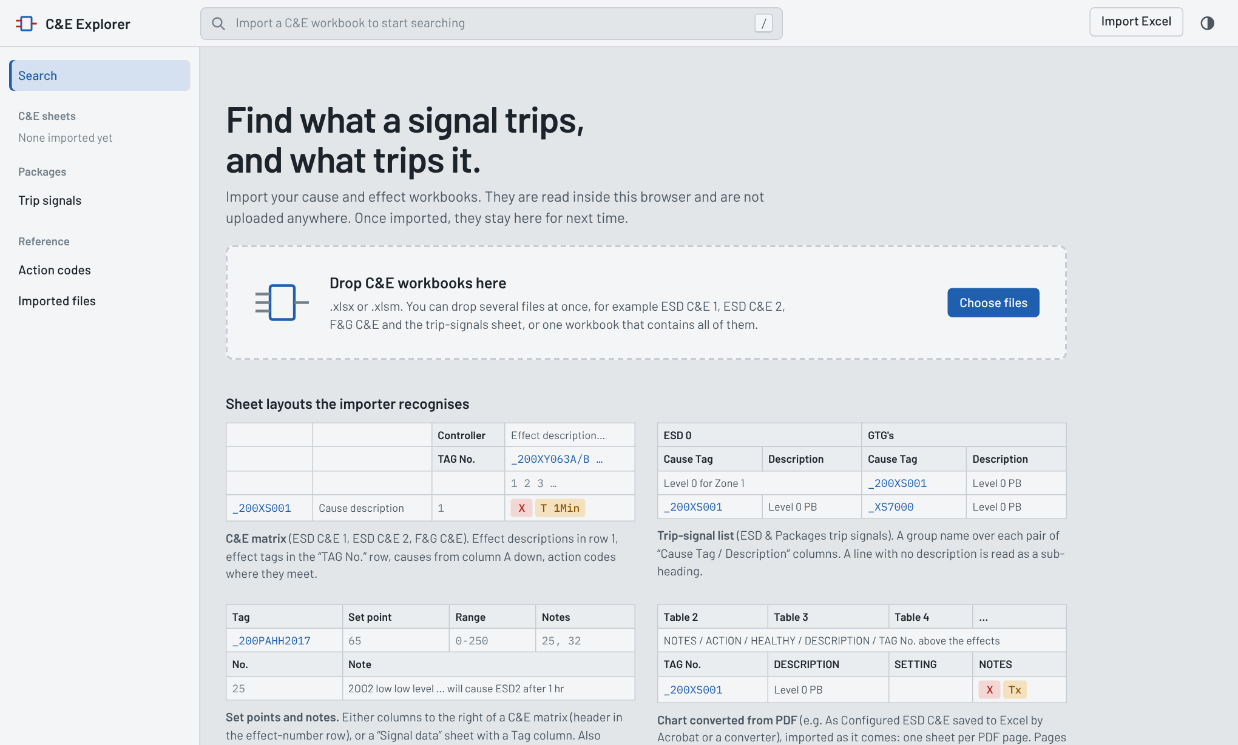
The screen has three fixed parts that stay on every page:
- Search box (top). Press / from anywhere to jump into it.
- Import Excel (top right) adds more workbooks at any time. The half-moon button beside it switches light and dark display.
- Side bar (left) lists every imported C&E sheet with its size (causes × effects), the Trip signals lists, and the Action codes and Imported files pages.
After importing, the start page shows one card per sheet. Click a card to open that sheet's matrix, or type a tag in the search box.
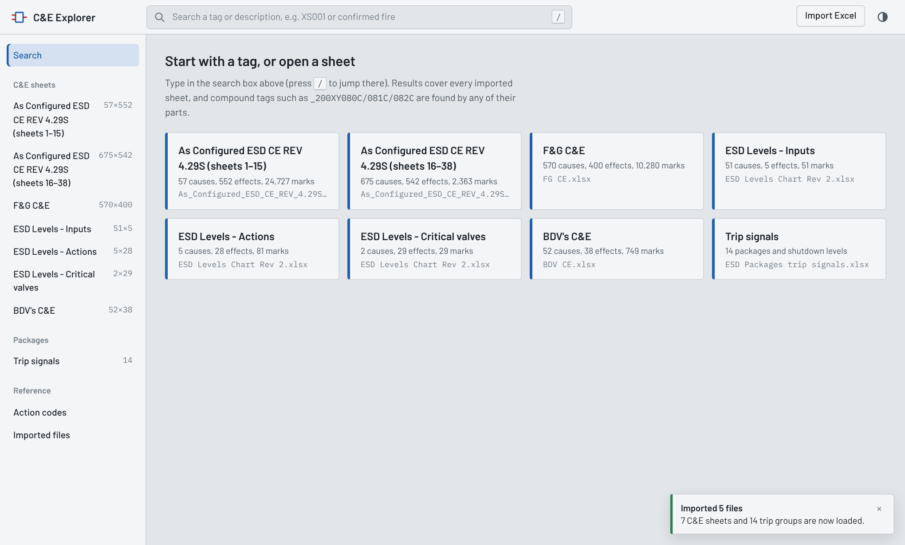

Importing files
Import any mix of workbooks in one go; the app recognises each sheet by its layout, not by its name.
- Click Import Excel (or drag the files onto the page).
- Select one or several .xlsx / .xlsm files. Old .xls files must be saved as .xlsx in Excel first.
- A message at the bottom right says what was loaded, for example “7 C&E sheets and 14 trip groups are now loaded”.
What you import | How it is recognised | What you get
C&E matrix (ESD C&E 1, ESD C&E 2, F&G C&E, BDV's C&E, ESD CE Rev 4.29S, ESD Levels Chart) | A TAG No. row with effect tags to its right; cause tags, descriptions and numbers in columns A–C | One matrix per sheet, with the action code at each crossing
C&E chart converted from PDF (e.g. As_Configured_ESD_CE_REV_4.29S.xlsx, one Table N sheet per page) | NOTES / ACTION / HEALTHY / DESCRIPTION / TAG No. labels above the effects and TAG No. / DESCRIPTION / SETTING … above the causes | Pages merged into two matrices (plant shutdown levels, unit and package trips), with set points, sections, effect actions and page notes
Trip-signal list (ESD & Packages trip signals) | Cause Tag / Description column pairs with a group name above | The Trip signals page
Set points and notes | Extra columns beside a matrix (Set point, Range, MOS, SOS, Healthy, Notes, Note text), a Signal data sheet with a Tag column, or a Notes sheet with No. and Note | Values and notes shown on each signal

The Imported files page
Imported files (side bar) lists every workbook, what was read from each sheet, and which sheets were skipped and why.
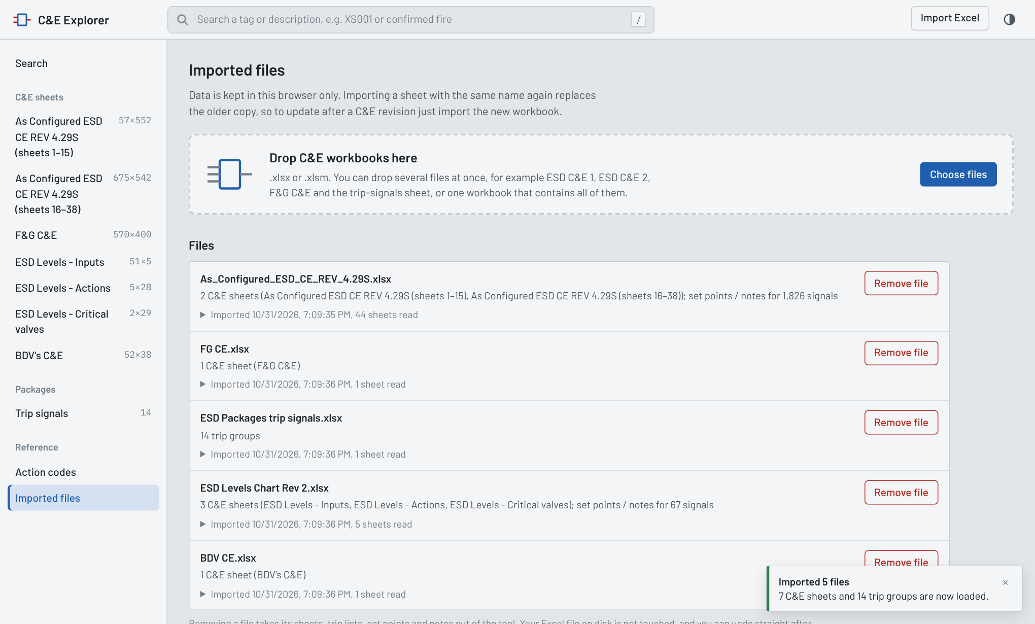
- Re-import to update. Importing a sheet with the same name again replaces the older copy, so after a C&E revision you simply import the new workbook.
- Remove file takes that workbook's sheets, trip lists, set points and notes out of the app. An Undo button appears straight after.
- Avoid duplicates. Don't keep two versions of the same chart loaded (for example the old ESD C&E 1 and the converted 4.29S chart); each signal would then be listed once per version.
Data is stored only in the browser you imported it into. A colleague on another computer, or you in another browser, imports the files there too.

Searching for a signal
Type any part of a tag or description in the search box; results appear as you type and cover every imported sheet.
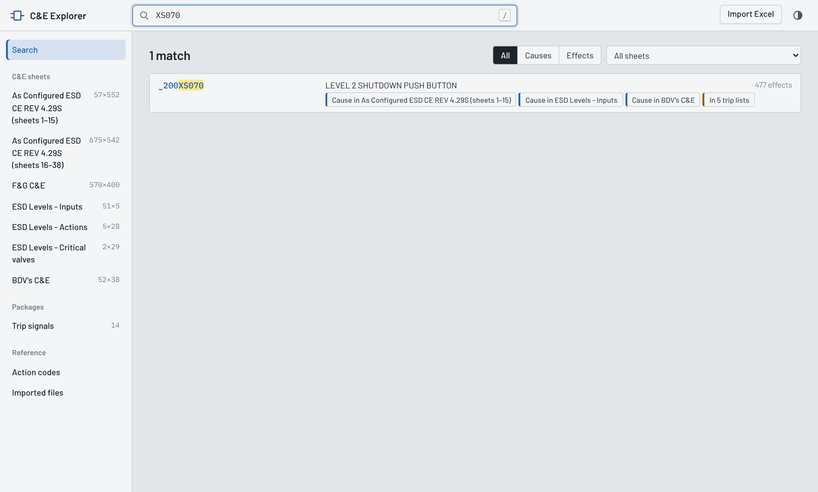
- Part of a tag is enough. XS070 finds _200XS070. Case, spaces and punctuation are ignored.
- Compound tags are split. _200XY080C/081C/082C is found by 081C too.
- Words work. confirmed fire or slug catcher searches the descriptions.
- Narrow the list with All / Causes / Effects and the sheet selector at the top right.
- Each result shows where the signal appears (“Cause in …”, “In 5 trip lists”), its set point (SP) and how many notes, causes and effects it has.
- Press Enter to open the first result, or use the arrow keys and Enter.
The start page also lists your Recently opened signals.

The signal page
Every tag has one page that gathers everything about it from all imported files: what it acts on, what acts on it, its data and notes, and the trip lists it is in.
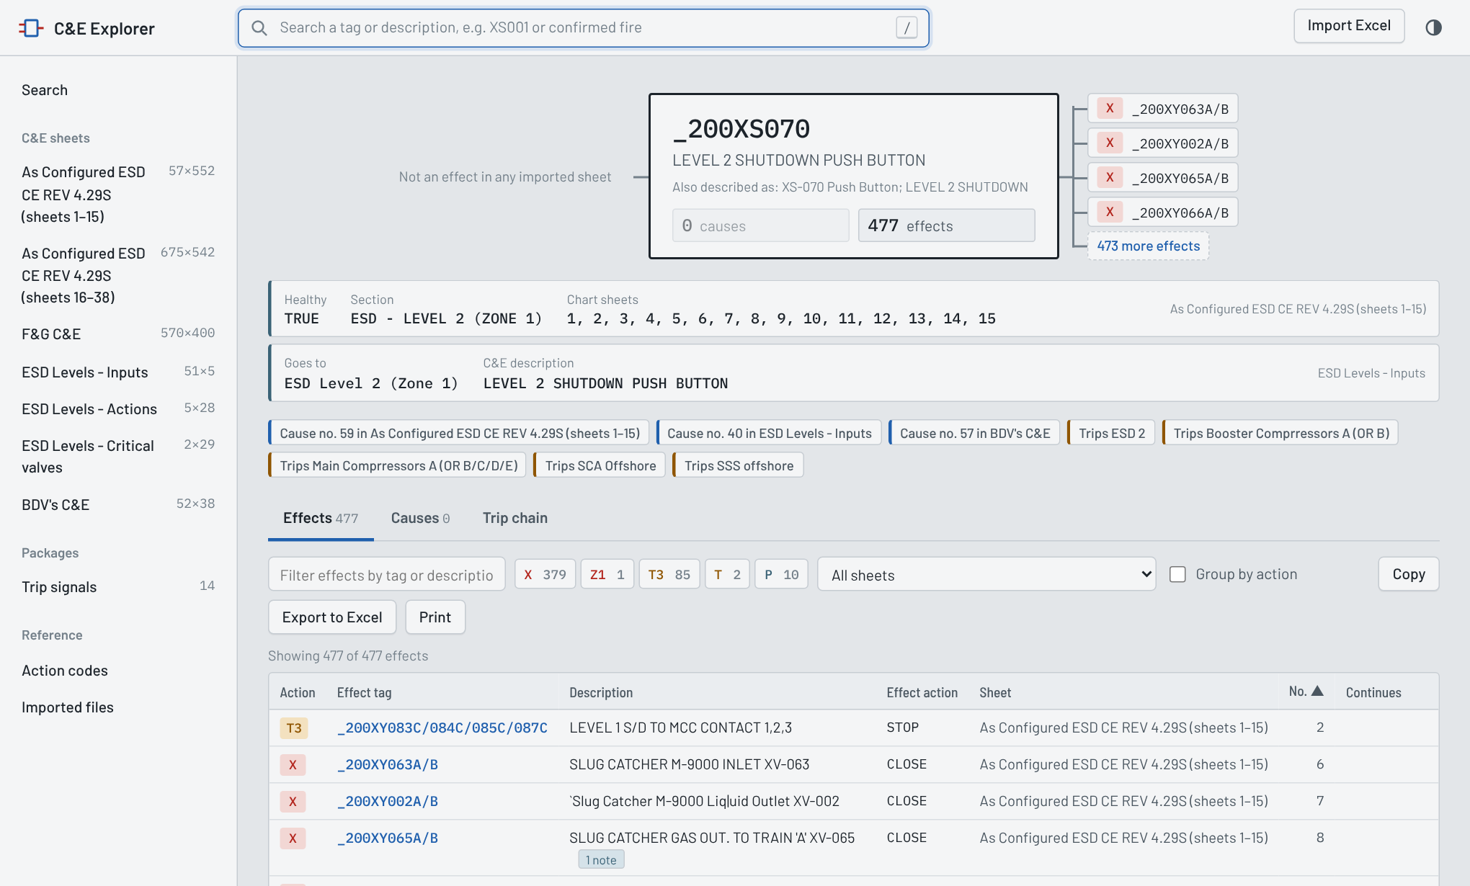
1. The header card. The tag, its description (and any other wording used for it in other files, “Also described as”), the set point and range, and the number of causes and effects. On the left are the causes that act on it; on the right, the first effects it acts on. Click any of them to jump to that signal.
2. Data and notes. One strip per source file with the values read for this signal: Set point, Range, MOS, SOS, Healthy, Section, Chart sheets, Action, and for the ESD levels chart “Goes to”. Below are the chart notes that apply to it, each with its note number and the sheets it is printed on.
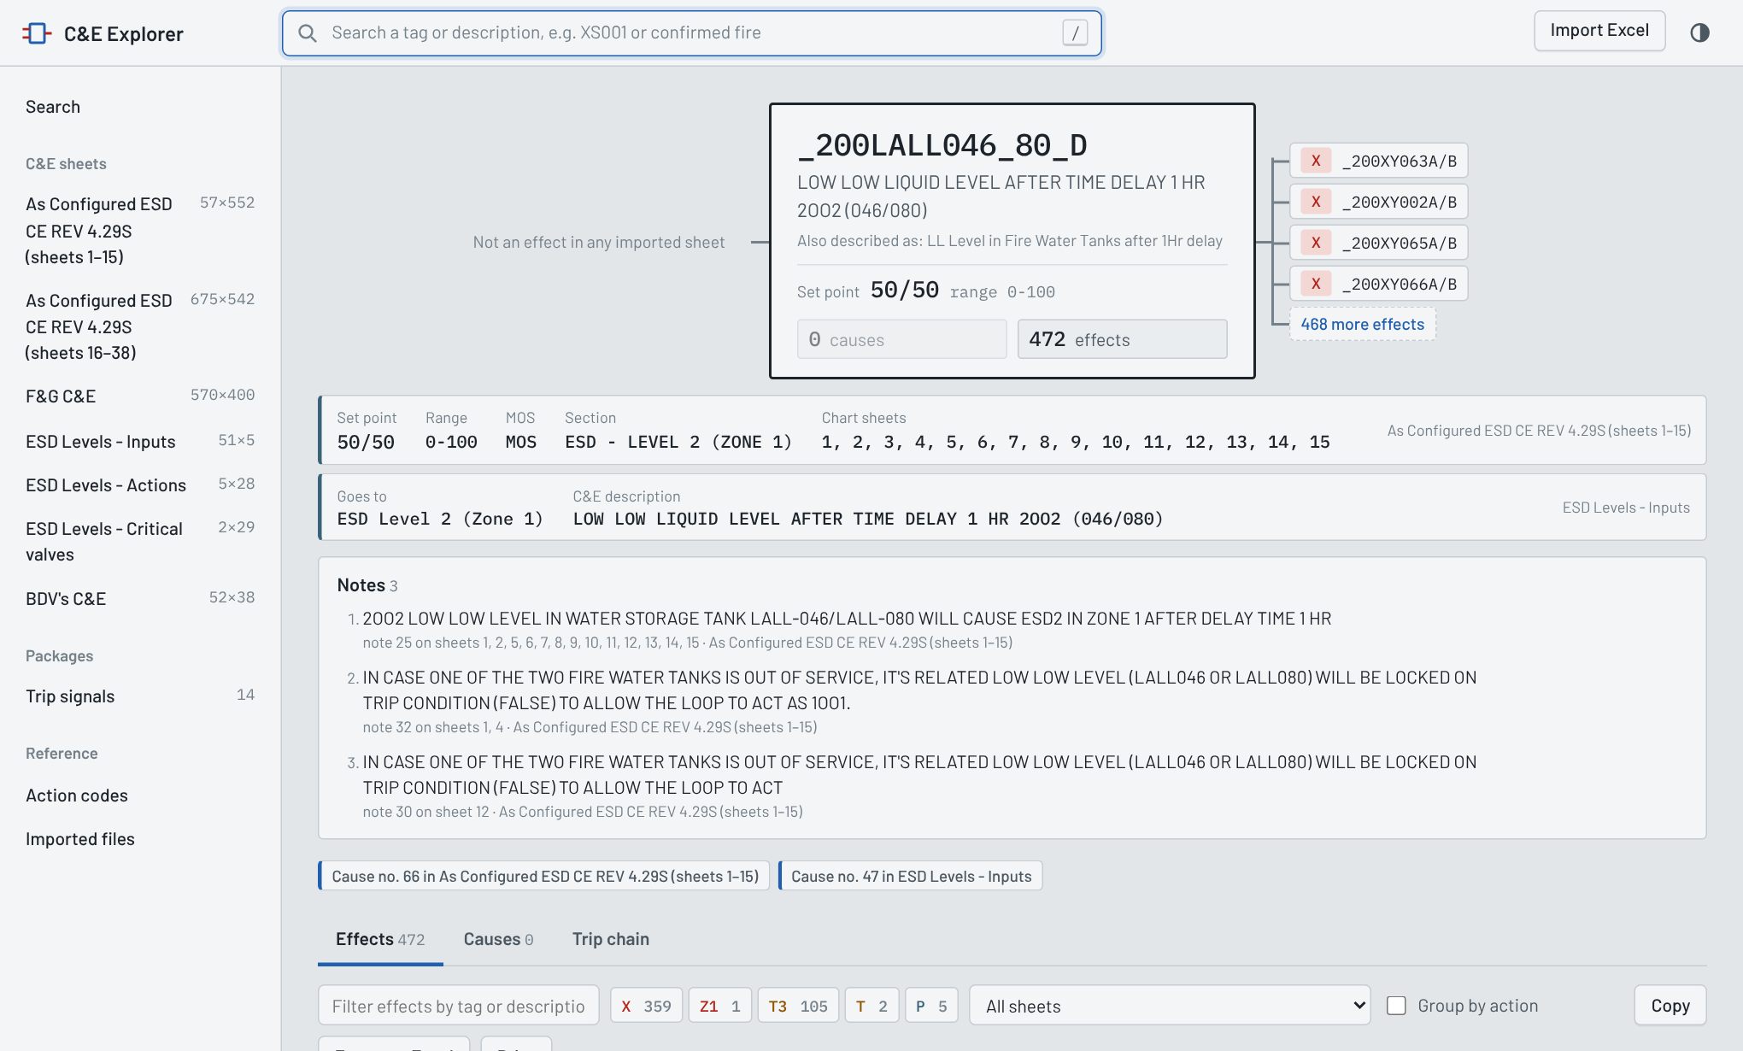
3. Where it appears. Blue chips (“Cause no. 59 in …”) open the matrix at that row. Brown chips (“Trips ESD 2”) open the trip-signal list it belongs to.
4. The tables. Three tabs:
Tab | Shows
Effects | Everything this signal acts on: action code, effect tag, description, effect action (CLOSE, STOP…), sheet, number, and “then N effects” when that effect is itself a cause elsewhere
Causes | Everything that acts on this signal, with each cause's set point and notes
Trip chain | The full sequence in both directions, followed across sheets (see below)
Tools above each table:
- Filter by tag or description.
- Code chips (X 359, T3 105 …) count each action code; click one to show only that code.
- All sheets limits the table to one sheet.
- Group by action splits the list by code (immediate, delayed, abort …).
- Copy puts the table on the clipboard for Excel or email; Export to Excel saves it as .xlsx; Print prints a clean list.
For a valve or other effect, the page shows the causes that close or open it:
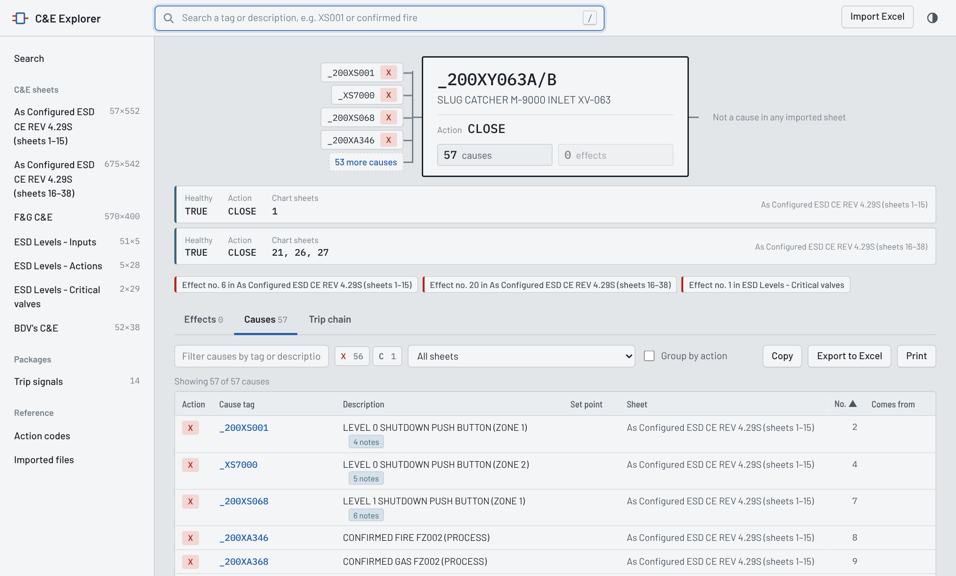

Trip chain
Some effects on one sheet are causes on another: a confirmed fire on the F&G C&E starts an ESD level, and the ESD level closes valves. Trip chain follows those links up to several steps.
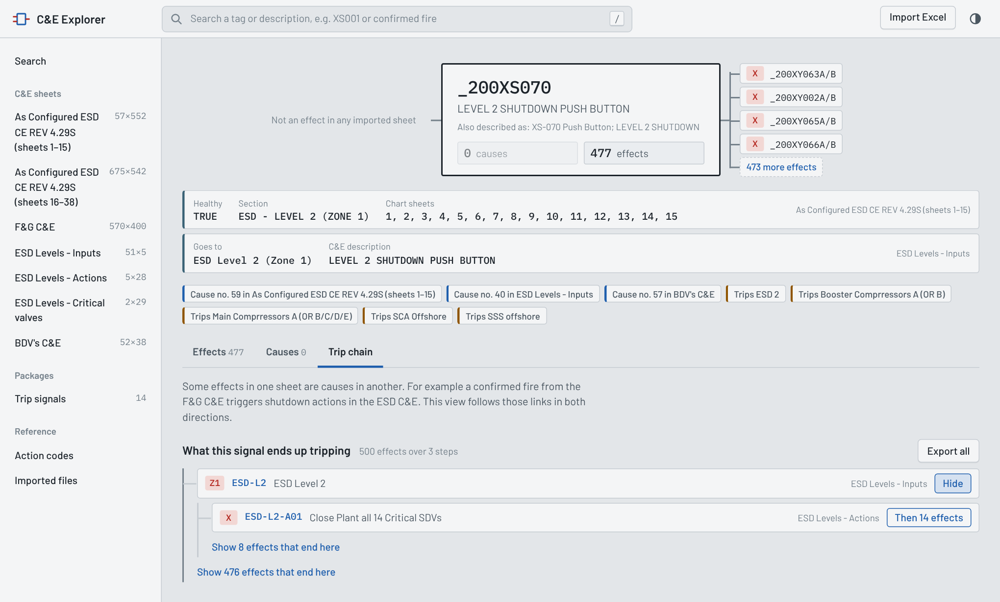
- What leads to this signal walks upwards to every initiating cause.
- What this signal ends up tripping walks downwards; “Then 14 effects” opens the next step, “Show N effects that end here” lists the final items.
- Export all saves the whole chain, with the step number of each item, to Excel.
The ESD levels have their own pages too. ESD-L1TD shows the inputs that start it (Z1/Z2), every action, and the levels it cascades into:
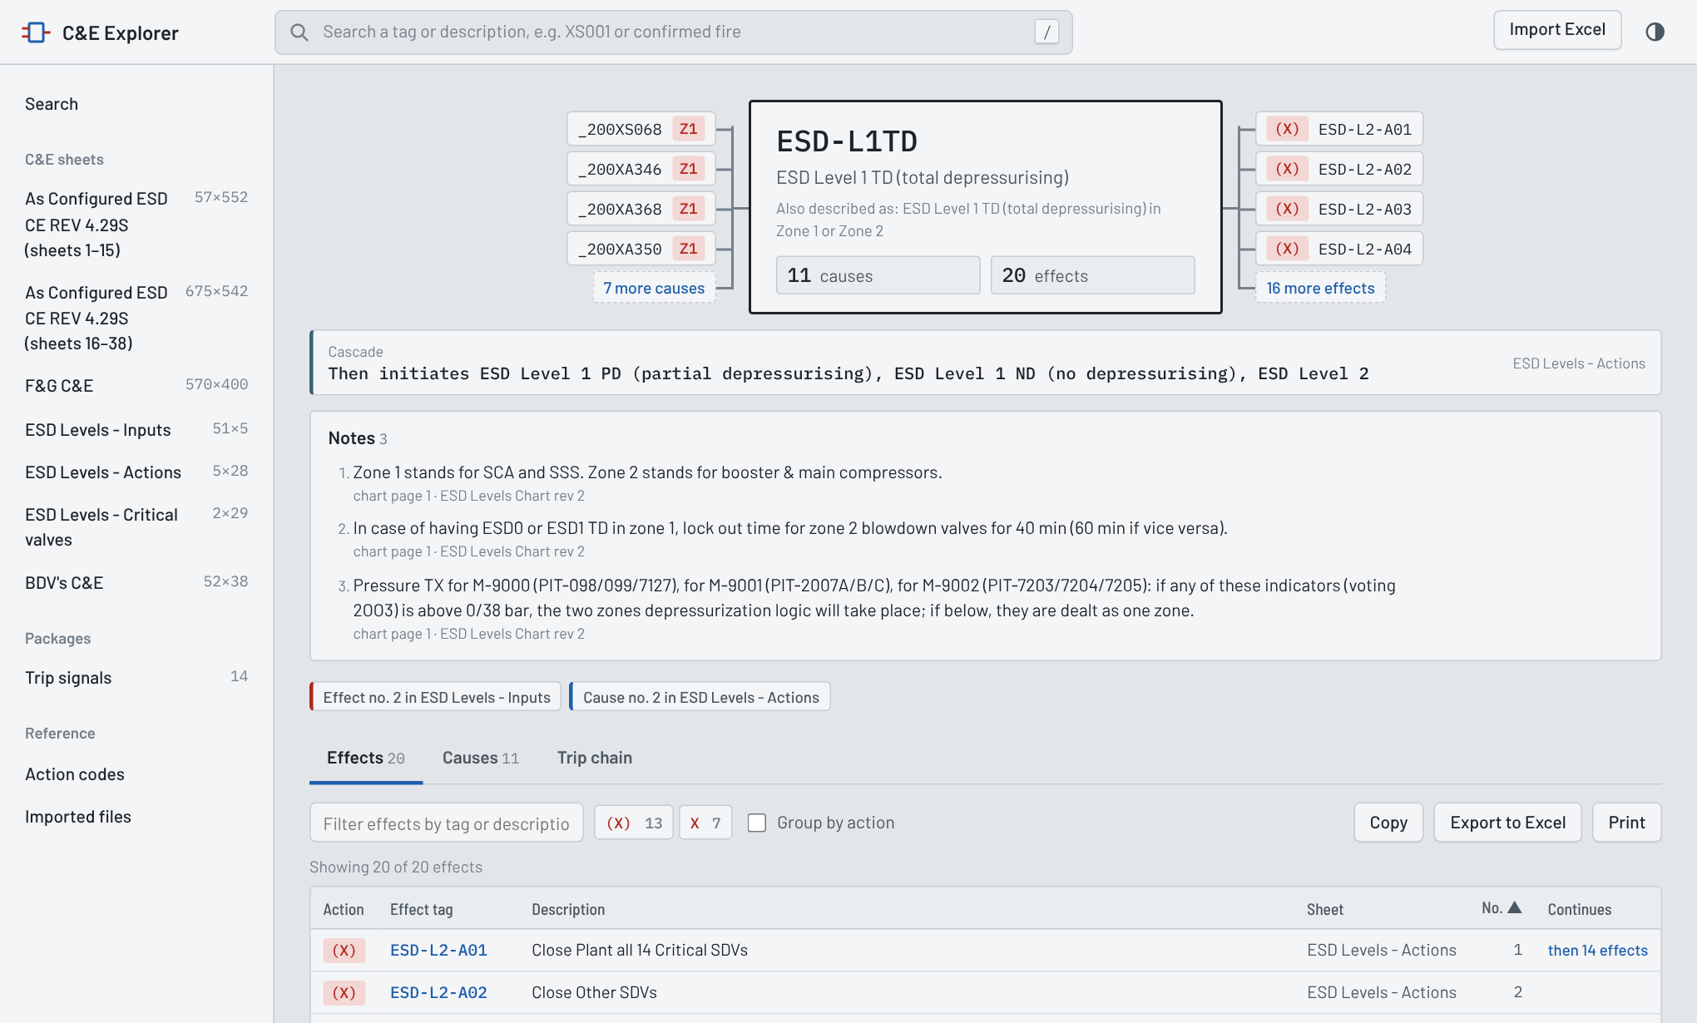

Matrix view
The matrix shows a whole C&E sheet as on the chart: causes down the left, effects across the top, coloured action codes where they meet. Open it from a sheet card, the side bar, or a blue “Cause no. … in …” chip.
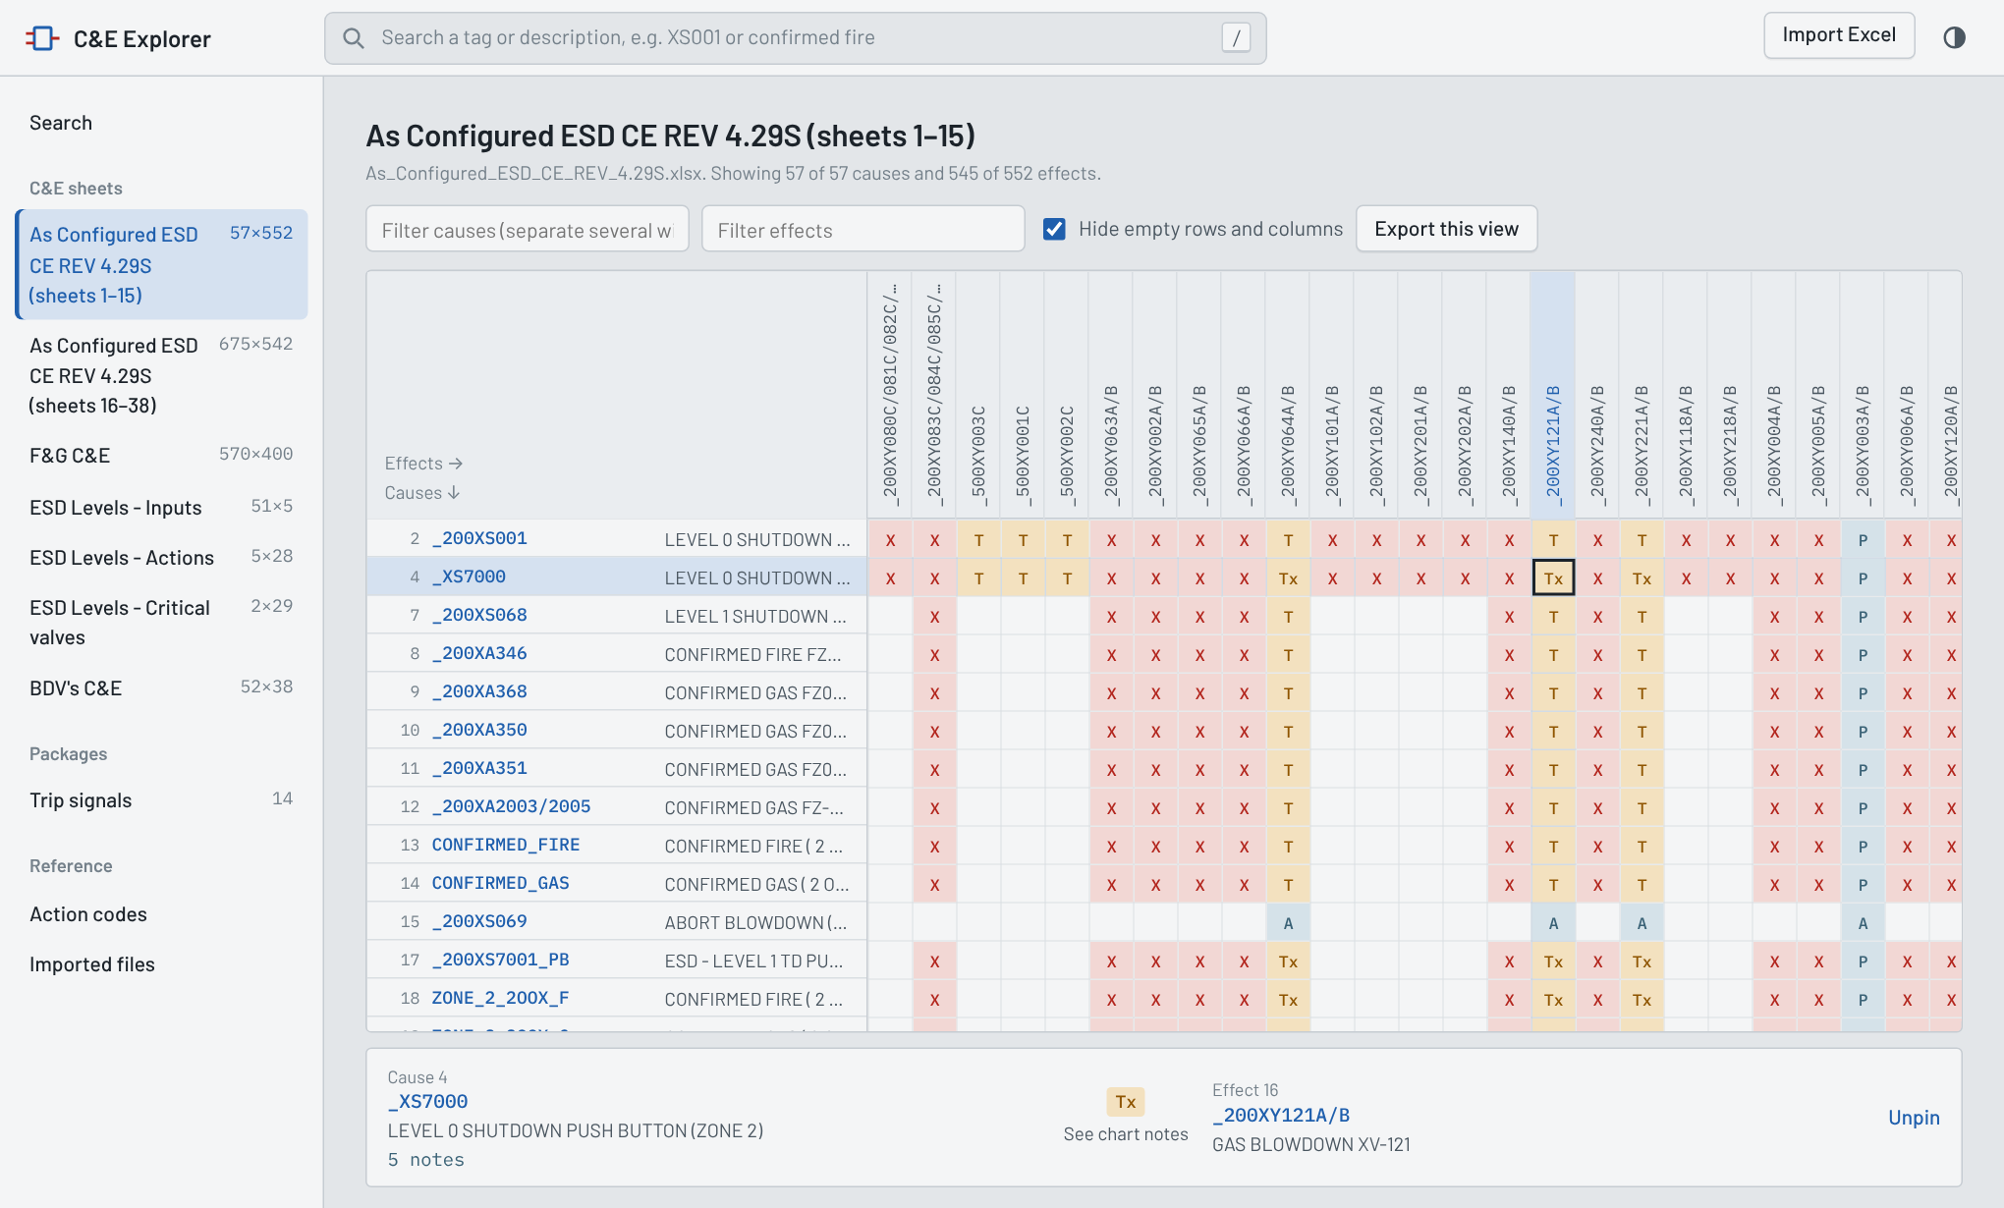
- Read a cell: point at it. The panel under the grid names the cause, the action code with its meaning, and the effect, with the cause's set point and number of notes.
- Pin a cell: click it, so the panel stays while you move. Click again or Unpin to release.
- Open a signal: click a tag in the panel or at the start of a row.
- Filter causes by tag or words; separate several with commas, e.g. XS001, XS068, XS070. Filter effects does the same for columns.
- Hide empty rows and columns (on by default) drops signals with no marks left after filtering.
- Export this view saves exactly what is on screen, filtered, as an Excel file with descriptions and set points.
Colours follow the code type: red = immediate action, amber = time delayed, blue = abort, inhibit and others. Big sheets scroll smoothly; only the visible part is drawn.

Trip signals
Trip signals shows the ESD & Packages trip-signal list: for each shutdown level or package (ESD 0, ESD 1 TD, GTG's, SCA Offshore …), the signals that trip it, under their sub-headings.
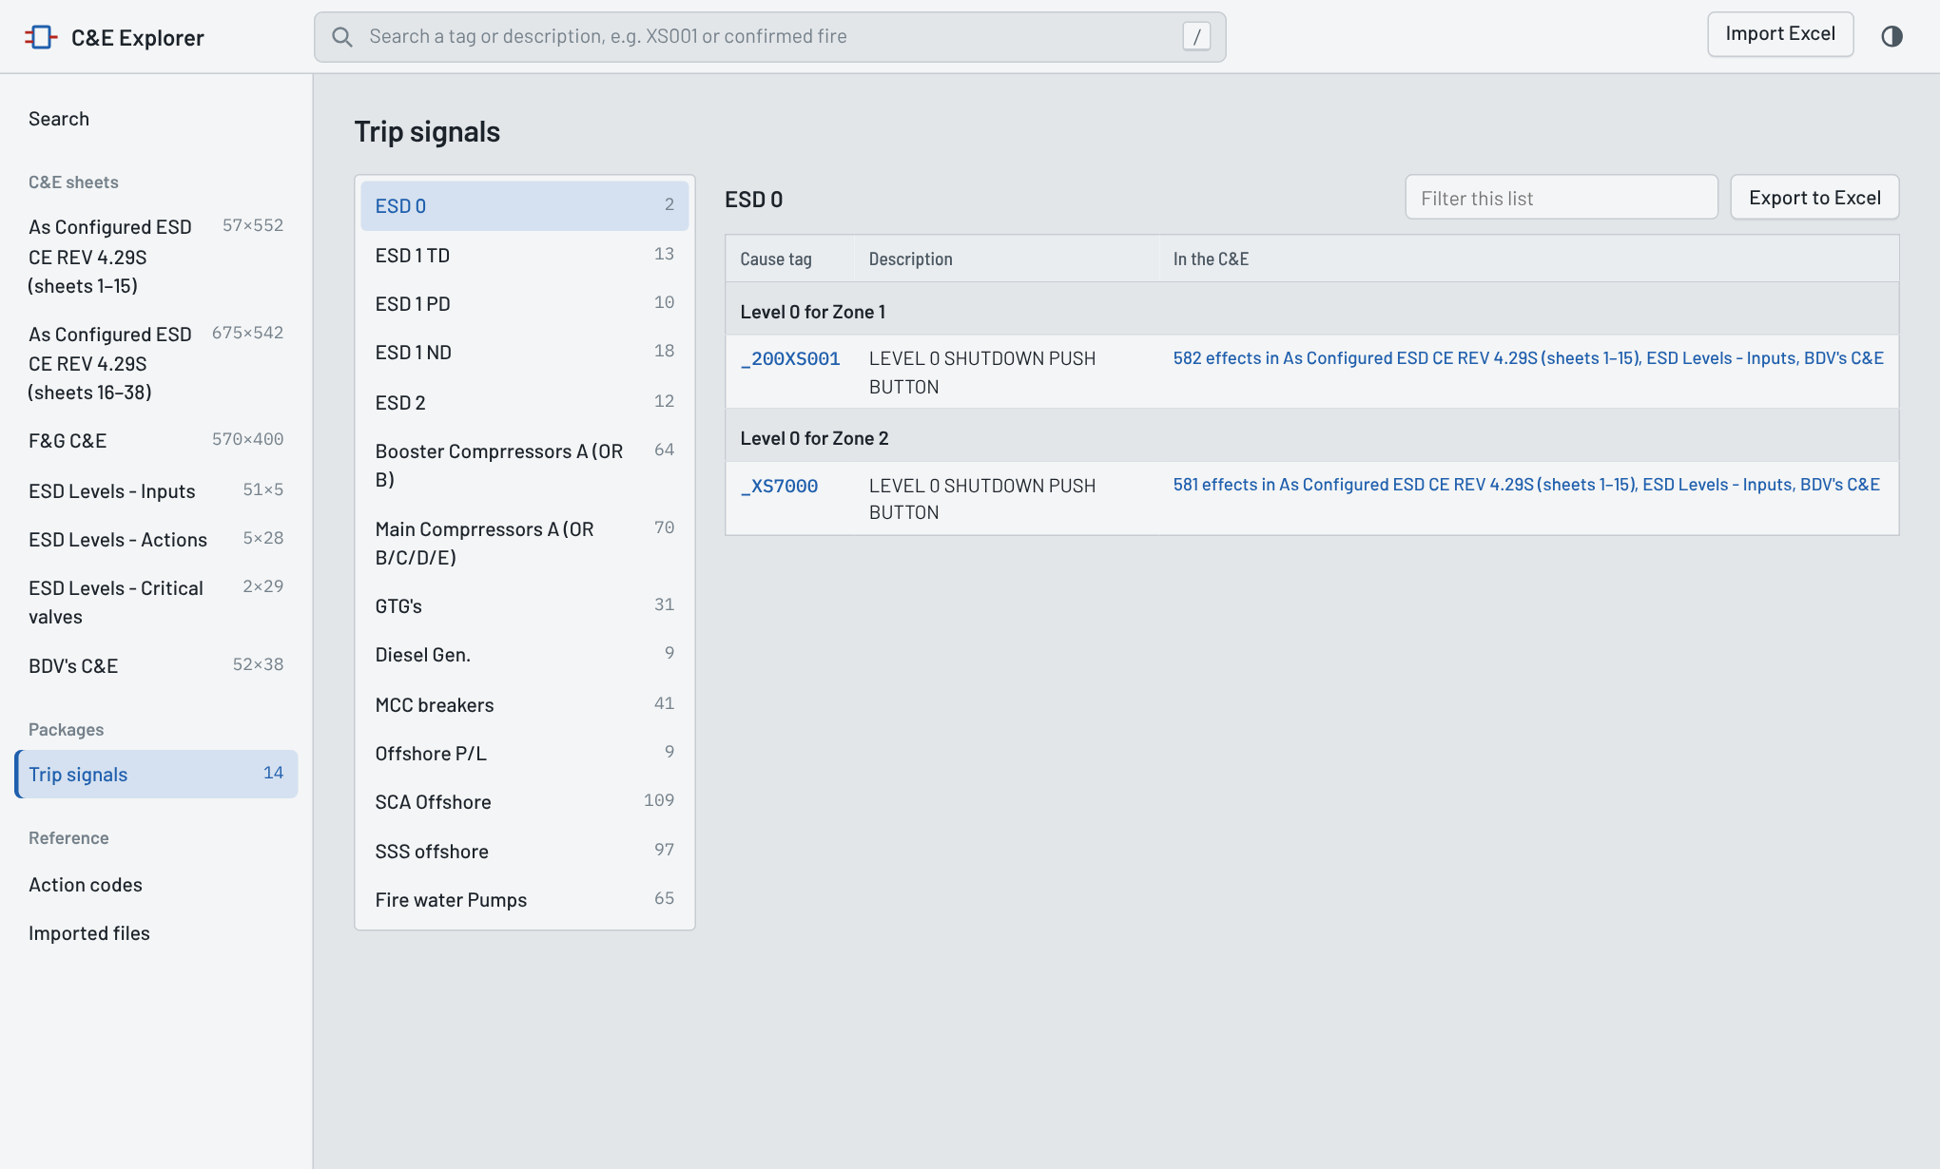
- Pick a group on the left; the number beside it is how many signals it holds.
- In the C&E links each signal to the sheets where it appears, with its effect count. Click the tag or the link to open it.
- Filter this list and Export to Excel work as on the signal page.
When a line says “Not in imported C&E sheets”, that tag is in the trip list but no imported C&E sheet has it as a cause or effect. Usually the chart covering it (for example a vendor package C&E) has not been imported yet, or the trip list spells the tag differently. Search for part of the tag to check; the app already matches common variants such as _210PIT7203/4/5 against _210PIT7203.

Action codes
The code at a crossing tells you how the cause acts on the effect; the meanings below come from the legends and notes of the ESD and F&G charts. The Action codes page in the app has the same list plus a count of every code in your imported sheets.
Code | Meaning | Colour
X | Cause initiates the effect immediately | Red
T … (T 1Min, T 3Hr, T 30Sec) | Effect initiated after the time delay shown | Amber
T | After a time delay given in the chart notes | Amber
T3 | After a 3-hour time delay | Amber
Tx / Ty | 1 min if slug catcher pressure is below 0 bar, otherwise 60 min (Tx) or 40 min (Ty) | Amber
Tz (X - T …) | No delay if slug catcher pressure is below 0 bar, otherwise after the delay shown | Amber
A | Abort blowdown within 1 min | Blue-grey
R | Reset | Blue-grey
H | Inhibit | Blue-grey
C / O | Package charts: valve or pump closed / open in that step | Blue-grey
M, MO, MC | Package charts: modulate, modulate open, modulate closed | Blue-grey
X1 / X2 | Package charts: first / second occurrence | Red
XS | Trip with the selector in the right position | Red
(X) | ESD levels chart: done through a lower level, because each level also starts the levels below it | Red (light)
Z1 / Z2 | ESD levels chart: the input starts that level in zone 1 (SCA and SSS) or zone 2 (booster and main compressors) | Blue-grey
N/A, - | Not applicable; kept in the sheet but not shown as an action | —
P and others | Shown exactly as written on the chart; check that sheet's notes | Blue-grey

Keeping it current and troubleshooting
After a new C&E revision, import the new workbook; sheets with the same name replace the old ones, and a renamed sheet is added beside them, so remove the old file afterwards.

Bringing in a C&E that only exists as a PDF
- Open the PDF in Adobe Acrobat and choose Export PDF → Spreadsheet → Microsoft Excel Workbook (other converters that keep one sheet per page also work).
- Import the resulting .xlsx as it is; don't tidy it first.
- Open Imported files and check each page reads “chart sheet N: … causes × … effects, … marks”. Cover, legend and blank overflow pages are listed as skipped, which is expected.
- Spot-check two or three signals against the PDF, especially on landscape pages and any page where the converter garbled the text.

Common questions
Situation | What to do
A signal is listed twice or its counts look doubled | Two versions of the same chart are loaded. Remove the older file on Imported files.
“No signal matches” | Try part of the tag (XS001 instead of _200XS001) or a word from the description.
“Not in imported C&E sheets” on Trip signals | Import the C&E that covers that tag, or search for the tag to find its spelling.
A note shows “not printed on chart sheet N” | The chart refers to a note number that the sheet doesn't print; check the PDF.
A sheet was skipped | Imported files says why. The sheet needs one of the layouts in Importing files.
My colleague doesn't see my data | Each browser keeps its own data. Share the Excel files; each person imports them once.
Start again from empty | Imported files → Remove everything.
Old .xls file | Open it in Excel and save as .xlsx, then import.

